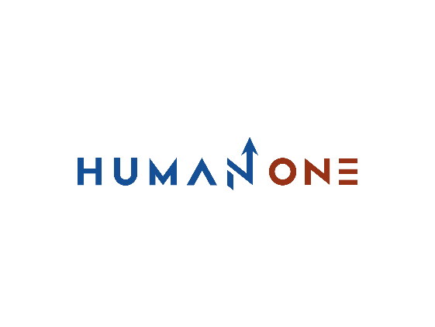

Services

Big Data & analytics

Platform Development

Expertise

**EN**

**FR**

Get in touch

Company

Cloud

Devops

Machine learning & IA

# **Maching learning & IA**

Let’s Talk

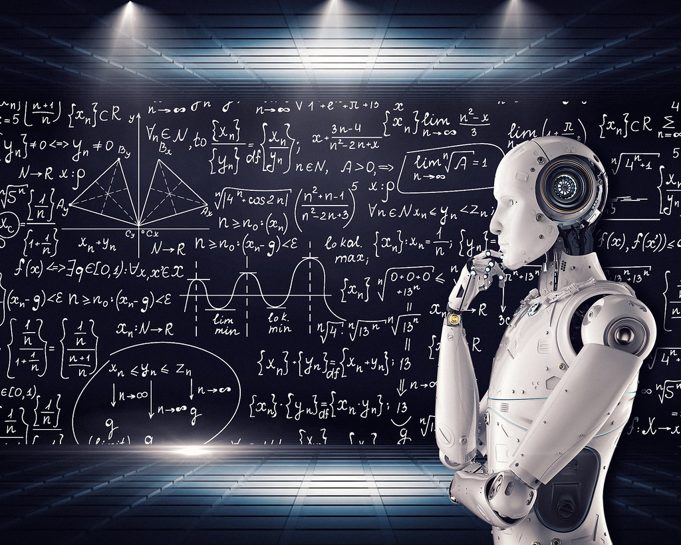

HumanOne applies deep technological expertise in machine learning and artificial intelligence development services to help clients deliver personalization and customer convenience at scale. Our R&D capabilities and artificial intelligence software development for rapid prototyping and custom machine learning solutions empower clients to tap into unseen market segments, become more efficient, and achieve measurable business outcomes. HumanOne strives to delight customers and augment businesses by delivering AI software solutions and machine learning development services.

**Key Machine Learning and Artificial Intelligence** development services at Intellias

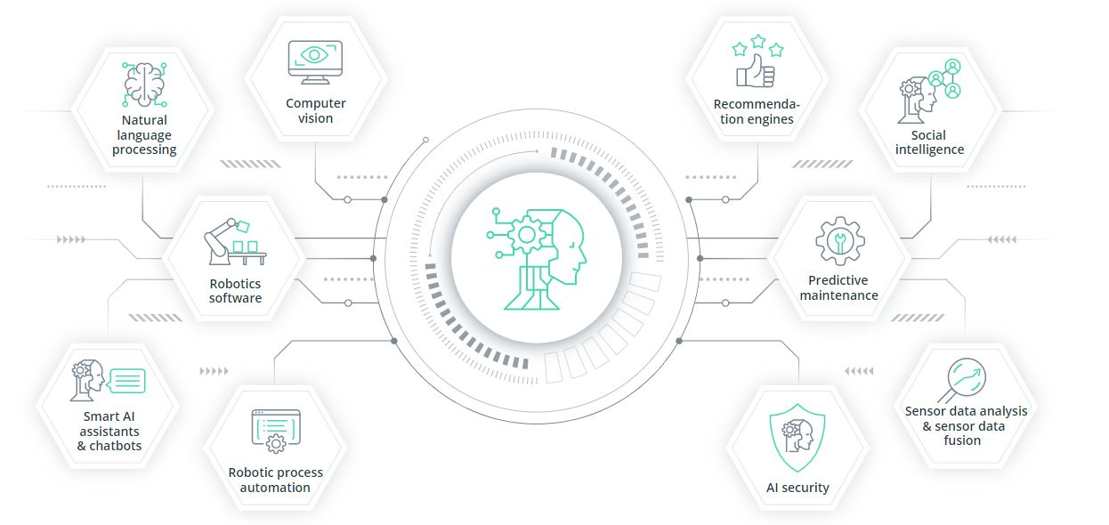

Start delivering personalization at scale

Get in touch

## **AI and Machine Learning R&D**

### Object recognition for automated driving

### Prediction of pedestrian movements

### driving



Our concept recognizes pedestrians on the road and applies machine learning algorithms to learn pedestrians’ behavior and predict their next move.

We applied computer vision and artificial intelligence development services to recognize objects around a car in real time to make automated driving safe for both pedestrians and drivers.

Let’s start your platform development process

Get in touch

## **What do you get from AI and ML development services?**

## **companies offer?**

### **Business outcomes of AI software solution adoption**

After implementing AI and machine learning development services to optimize defined business functions, you may need to evaluate the benefits that AI software solutions bring. Some benefits will be common for all companies, such as automation of routine tasks, enhanced analytics, and increased efficiency thanks to better processing of large data volumes.

Other business outcomes may differ across industries. Retail companies may expect an increase in sales and reduced customer churn due to improved targeting of customers’ needs and tapping into new market segments. The automotive and urban mobility sectors will win from autonomous vehicles, financial services will gain improved security and fraud detection, and healthcare will benefit from automated medical diagnoses

### **Most common AI development services you can get**

When integrating machine learning and AI software solutions into business needs, you have to clearly define the deliverables you’ll get at each stage. Early adopters of AI development services may benefit from labeled data sets for evaluation and training of machine learning models, advanced analytics for data-driven predictions, and automation of routine tasks.

Moving forward, AI adopters can integrate already designed and trained neural networks into their machine learning solutions to increase efficiency at a lower cost. Another scenario is to introduce computer vision technology to recognize critical objects from video or another multimedia data source. When finalizing your AI implementation, you should approach a mix of machine learning solutions and models and integrate tools to visualize business outcomes

**AI development services across various industries**

AI development services are mainstream. Most companies across industries are striving to adopt open-source and commercially available AI and machine learning solutions. Still, the market demands custom AI solutions for narrow needs. Adoption of AI development services goes hand in hand with the adoption of other technologies.

Integration of custom machine learning development and artificial intelligence software development with IoT and edge computing is expected to bring new possibilities for global businesses. Despite fears of AI stealing today’s jobs, people and machines should work together as a team to unleash the full potential of this technology. The AI augmentation of human engineering capabilities is expected to be key to the success of AI-integrated solutions.



